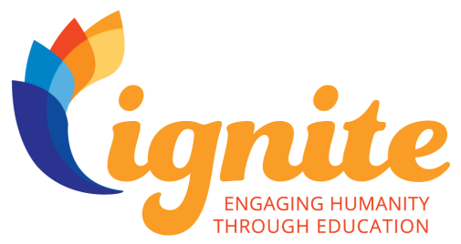
Dear Potential Partner,
We are excited to share an opportunity with you! Our ICF Chapter is participating in a global project in partnership with the International Coach Federation Foundation called Ignite: Engaging Humanity Through Education. This initiative is a pro bono coaching program that focuses on The UN 2030 Sustainable Development Goal of Education.
Through Ignite, we believe our coaches can help build capacity in accelerating your organization’s impact, and in turn will move forward the goal of ensuring inclusive and quality education for all and promoting lifelong education. We believe that coaching is transformative, for coaches and organizations who see their work to ignite social progress in the world. We want to collaborate with you!
What is coaching?
ICF defines coaching as partnering with clients in a thought-provoking and creative process that inspires them to maximize their personal and professional potential.
Coaching is a process and partnership which allows you to accelerate forward, especially when you’ve been stuck. By realigning your momentum, your life becomes easier, more peaceful and fulfilling. A coach won’t tell you what to do or give you all the answers. A coach is objective, non-judgmental, an excellent listener, and helps you to uncover the strategies and steps forward that work best for you. As a client, you are responsible for the commitment to achieve the agreed upon action steps and for your own success.
How will coaching benefit your organization?
Working with our coaches allows your employees to:
- Achieve goals you’ve never thought possible – personally and professionally
- Gain new insights and expand possibilities
- Become more balanced in their lives
- Become focused on what’s most important and fulfilling
- Optimize inner trust, intuition and self-worth
- Achieve more with an accountability partner
Your organization will receive coaching from our ICF Chapter. They are International Coach Federation members and ICF Credentialed Coaches. Would you be willing to meet with our Ignite Project Manager to discuss the possibility of partnership?
Sincerely,

