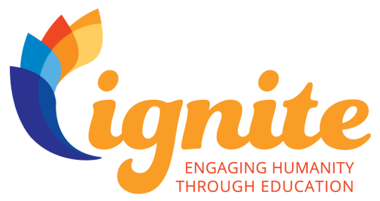

Ignite Chapter Agreement

We, _______[ICF Chapter]______, agree to work with the ICF Foundation Ignite: Engaging Humanity in Education on a pro bono project by participating in the Ignite Initiative within the timeframe of August 2017 to December 2019.
By signing your chapter up for participation with Ignite: Engaging Humanity Through Education, the chapter is agreeing to follow the criteria listed below:

Designate an Ignite Project Manager
We agree to assign an Ignite Project Manager to act as the point of contact with the ICF Foundation through the full term of the Ignite Initiative (which may cross over your chapter’s fiscal year). This Project Manager will act as a liaison between the Chapter and ICF Foundation, sharing information and best practices.
Adhere to Ignite Measurements and Data Collection
The chapter agrees to collect the criteria required for measurement as determined by the ICF Foundation. We understand that this will include, but not be limited to, specific measure relevant to the UN’s goals for impact, sharing the mid and end-point survey with Coachees and other data as requested by the ICF Foundation.

Selection of Ignite Partner
The chapter agrees to involve a partner that will align with the UN 2030 Sustainable Development Goal #4 Education, focus on ensuring inclusive and quality education and promoting lifelong learning. The partnership will “help the helpers,” coaching leaders and managers of nonprofits and NGOs to meet the challenges they face and move education forward.

Pro Bono Coaching Criteria
The Ignite Initiative requires that the pro bono project will be a maximum length of either ten (10) sessions or six (6) months, whichever comes to fruition first. One goal of the program is to provide the partner organization an experience that will act as a catalyst to adoption of professional coaching for their organization. Chapters should recruit Associate Certified Coaches (ACC) with one renewal, Professional Certified Coaches (PCC) and Master Certified Coaches (MCC) to provide pro bono coaching for the Ignite Initiative.

Confidentiality
Chapter and Member volunteers are responsible for maintaining the confidentiality of all proprietary or privileged information to which they are exposed while serving in the Ignite Initiative, including information involving a single staff, volunteer, client, or other person as well as overall Foundation business. Failure to maintain confidentiality may result in termination of the Chapter or Members’ relationship with the organization.

Copyright/Ownership Issues
_______[ICF Chapter]______ hereby grants non-exclusive permission to the ICF Foundation for use of any materials produced for the Ignite Initiative, including graphic materials, web page designs, narratives, research, compilations, instructional texts, etc., to become the property of the Ignite Initiative upon submission. Chapters will receive credit on the ICF Foundation website for these and other contributions.

Indemnification
_______[ICF Chapter]______ agrees to defend, indemnify and hold harmless the ICF Foundation, its officers, trustees and employees from any and all claims, demands, actions, and/or damages, losses and liabilities arising directly or indirectly out of or cause by the chapter’s use of the ICF Ignite name, logo or mark in a manner inconsistent with or in violation of this agreement, the ICF Chapter requirements issued to Chapter, or Limited License to use marks and logos of the ICF Foundation Ignite Initiative.

This agreement has been shared with the Board of Directors of this Chapter and a resolution has been passed to support this program and the terms of this chapter agreement.

Date |  | ICF Chapter President
 |  | Ignite Project Manager

